Business Report:

LoxkMe Company

By

Mr. Waris Damkham 6388014

Miss Pattanan Korkiattrakool 6388022

Mr. Thanakij Pinyoboon 6388097

Submitted to

Mr. Cheng-Chang Chien (Peter Chien)

ITLG301 Business Writing

Faculty of Information and Communication Technology

Mahidol University

2021

**Table of Contents**

**Executive Summary page** 1

**Client Profile: BDMS Group** 2

**Client Background** 3

**Research and Analysis** 5

**Competitors Analysis** 5

**Client Problem/Need** 9

**Cause of Problems** 9

**Effect of Problems** 9

**Solution for client** 10

**Expected Outcome** 10

**Process/Instruction** 11

**Conclusion** 13

**References** 14

# **Executive Summary page**

The objective of the business report is to examine and understand the client scenario. This report focuses on a step-by-step solution for the client based on client SWOT analysis to help identify the origin and trigger point of the problem so that it can get to the root of the problem. The report's purpose is to research and analyze client problems and needs, to look for the proper solution to solve client issues. Furthermore, to get advantages over competitors for sustainability for the client's future.

     The business report consists of:

* Client and business profile
* Client's business background (including competitors)
* Research & Analysis of client problems and requirements
* Solution with Explanation
* A process on how the company (LoxkMe) works to solve client problems.

**Introduction**

## **Client Profile: BDMS Group**

     Good system management should not only be about the location but also the internal and external aspects. The external aspect refers to the individual system with excellent maintenance and service. The internal part refers to various internal administrations ranging from Database Administration, Networking and Security, and Evaluating the outcome of the possibility. A good network to transmit data and prevent data leakage is what BDMS Affiliated Hospital needs the most right now. Including organizing and maintaining a new database system to tidy up the management of large amounts of personal and patient data. With these features, BDMS hospitals are able to hit the market and expand the number of clients and profits more than ever. It can also gain a competitive advantage over medical competitors.

**Client Background** Bangkok Dusit Medical Services Public Company Limited (SET symbol: BDMS) is Thailand's largest private hospital operator by patient services revenue and market capitalization with assets of THB 94.0 billion as of June 2015. Doctors, pharmacists, and 30 nurses opened the 100-bed facility in 1972. It targets Bangkok and high-growth markets in Thailand and abroad. The company aims to be the leading healthcare provider by meeting Thai and foreign patients' needs with high-quality, internationally recognized standards, value for money, and cutting-edge medical technology.

The company currently has a registered capital of Bt1.65 million and paid-up capital of Bt1.55 million. In addition, the company has 40 hospitals in Thailand and 2 hospitals in Cambodia. The company operates under six hospital groups, namely Bangkok Hospital, Samitivej Hospital, BNH Hospital, Phyathai Hospital, Paolo Memorial Hospital and Royal Hospital. The company's network also includes businesses that support medical care, such as medical laboratories, drug manufacturing, and saline production.

Bangkok Hospital: The company has 19 branches throughout Thailand with 2,936 beds for its patients. Bangkok hospitals provide specialized medical services and have excellent facilities for patients with luxury needs in terms of state-of-the-art medical technologies.

Samitivej Hospital: Samitivej Hospital provides international level healthcare services by providing multilingual staff and international services such as interpreters and immigration services for foreign patients. Currently, the hospital has 6 branches located in Sukhumvit, Srinakarin, Sriracha, Thonburi, the Children's Hospital and Chonburi.

BNH Hospital: The hospital provides medical services of the highest quality with specialists and general practitioners who take complete care of patients, from consultation and diagnosis, to planning and implementation of treatment, to follow-up of results, and in surgical cases and postoperative card with a concept of family doctor

Phyathai Hospital: The hospital has 1,340 patient beds in 3 branches Phyathai 1, 2 and 3, each of them has a different specialty. Phyathai 1 focuses on esthetics center and mini spine center. Phyathai 2 specializes in dermatology and women's clinics, while Phyathai 3 focuses on pediatrics and children's centers.

Paolo Memorial Hospital: The 260-bed private hospital offers exceptional services in all major areas such as neurology, cardiology, bone and joint diseases, spine center, surgery, G.I. liver, women's center, fertility center, pediatrics, dentistry, rehabilitation and check-up center.

Royal Angkor International Hospital: Another private hospital in Cambodia. There are only 2 branches with 130 patient beds

# **Research and Analysis**

## **Competitors Analysis**

*SWOT Analysis of Competitor 1: BUMRUNGRAD HOSPITAL PUBLIC COMPANY LIMITED*

|  |  |
| --- | --- |
| STRENGTHS   * Specialized medical teams with expertise in every field of Asia. * Convenient transportation on the road, near the BTS and there is a helicopter center on Rooftop for pick-up and drop-off Case Emergency and service recipients from foreign countries nearby * An information system equipped with modern and complete medical equipment equivalent to abroad * Cash flow management is systematic and liquid. * Personnel at all levels Providing services based on Service Mind and able to communicate can English | WEAKNESSES   * High expenses related to salary and welfare of personnel * The hospital's medical expenses are higher than those of competitors. * Some groups of Thai people feel dissatisfied, thinking that it is a hospital for foreigners with expensive medical expenses. |

|  |  |
| --- | --- |
| OPPORTUNITIES   * Differences in medical prices between countries are different but the efficiency of medical care is the same. * Insurance abroad does not cover many diseases. conducive to Thai health services such as eye surgery, dentistry, and surgery, which in foreign countries will have very expensive treatment costs. cause to seek | THREATS   * Political instability, economic downturn Causing people to save money not to spend if it is not necessary or when they are sick, they will seek cheaper sources of health services. * The situation in the country is not peaceful causing foreigners to distrust and come to do business or travel less. |

*SWOT Analysis of Competitor 2: CHULARAT HOSPITAL PUBLIC COMPANY LIMITED*

|  |  |
| --- | --- |
| STRENGTHS   * One of the leading private hospitals in the eastern zone of Thailand with * 3 medical stations are accredited by Thai Hospital Accreditation and JCI from USA. * Competitive price for low to middle income people who is seeking for qualitied medical services which are the major population of the country. | WEAKNESSES   * High expenses on doctors’ salaries and lack of doctors in the industry. * SSO patients in some cases contains high cost of services but the revenue to hospital is fixed by Social Security Organization |
| OPPORTUNITIES   * Medical stations are all located near residential zones. Soon, there will be more people moving into these zones following economic growth. * Healthcare Trend & Population aging. * Healthcare expense cheaper compared to SEA * Technology Advancement | THREATS   * Many competitors with a strong network are targeting the same group as the company does. * World economy including Thai economy has not been growing as expected. * Risk of SSO program patients with actual high cost of medical services could decrease profit margin. |

*SWOT Analysis of Competitor 3: Bangkok Chain Hospital Public Co Ltd*

|  |  |
| --- | --- |
| STRENGTHS   * The Company have three brands of the hospital which categorized by their types of target customers and level of excellent cares * Increase in Operating Income * Technology and innovation is crucial for sustained economic growth for the medical and healthcare sector. | WEAKNESSES   * Increasing Trade Receivables * Low bargaining power of suppliers, most of private hospitals have own companies to purchase drugs and source medical equipment. * Low threat of new entrants * The private hospitals require high investment |
| OPPORTUNITIES   * Strategic Initiatives * The government has a policy to encourage public access to health services. * Health expenditures is lower than other countries * The strong support from government to promote Thailand 4.0 by putting healthcare as one of a priority sector | THREATS   * Changes in Government Regulations * Many competitors with a strong network are targeting the same group as the company does. * The patients can choose to seek treatment in public hospitals or clinics |

## **Client Problem/Need**

Businesses and whole industrial sectors are continually adapting to the fast growth of technology to enhance the efficacy and quality of the goods and services they provide in today's global economy. For some firms and people, the technology is, nonetheless, extremely new. As an example, the fact that certain hackers can enter our system, or the system utilized by the organization creates technical deficiencies that some people believe to be vulnerabilities that pose a threat to a company's or an individual's assets.

## **Cause of Problems**

In today's world, businesses and whole industrial sectors are constantly evolving in response to the rapid rise of technology to boost the efficiency and quality of the products and services they supply. To keep up with the changing times, this is done. However, technology is still relatively innovative for certain companies and individuals. As an example, the fact that certain hackers can enter our system, or the system utilized by the organization leads to technical deficiencies that some people believe to be vulnerabilities that pose a threat to a company's or an individual's assets. This makes it hazardous to businesses and private property.

## **Effect of Problems**

If no changes or interventions are made to address the issue, our customers will face the same risk of having their company systems hacked as if Facebook had been compromised in 2021. that can access 500 million accounts containing sensitive information such as real names, addresses, birth dates, e-mail addresses, and phone numbers. This resulted in a sharp decline in the company's stock price due to cybersecurity concerns; this is an example of the impact on our customers if the change had not been made.

# **Solution for client**

Store Database in the cloud

Cloud storage has given users the ability to share and access files remotely without access to their local storage systems. BDMS has many hospitals in its chain, the cloud storage will give the benefit to forward information to affiliated hospitals and helps to reduce the time for data forwarding the old way.

Cybersecurity for cloud database

Cloud security is a set of policies, strategies, controls, procedures, and practices to protect data, resources, and applications hosted in the cloud. It provides multiple layers of protection within the network infrastructure against data breaches, unauthorized access, DDoS attacks, etc. This will make patients or other data safe through multiple layers of protection of our cybersecurity.

## **Expected Outcome**

The customer's business provides all-encompassing services, covering every angle. including internal systems such as customer data and company databases, all of which are well maintained and stored with the help of the advanced security system provided by LoxkMe, which is also included. Our customers' businesses have experienced massive growth in the number of customers as well as an up to 20% increase in revenues and profits as a direct result of the system's internal development.

# **Process/Instruction**

     We are committed to securing and maintaining client information in every case, to facilitate BDMS-affiliated hospitals. Our main objective is to prevent the risk of information and security strategies that enable a business to compete and have sustainable growth in the global information economy. Thus, we came up with the solution of maintaining and managing the system from the beginning to the end for the BDMS group.

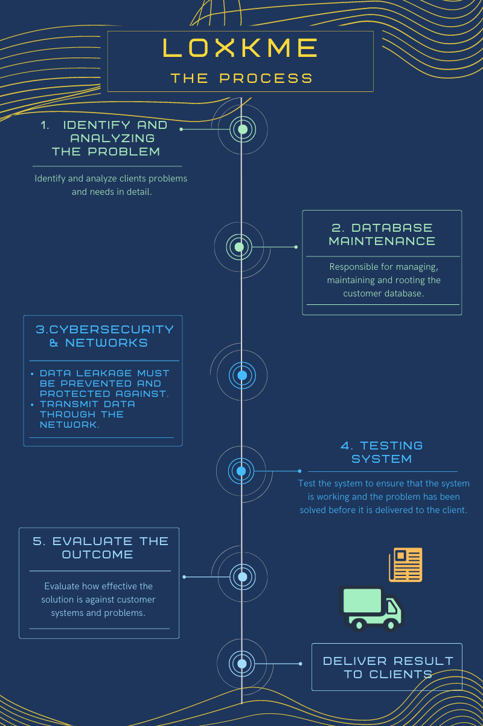

* Step 1: Identify and analyzing the problem
* Inquire with the BDMS group to identify and analyze the problems and detailed requirements to use the information to find the right solution for the client.
* Step 2: Database Maintenance
* Responsible for managing and maintaining the customer database whether redesigned or laying in a suitable structure.
* Step 3: Cybersecurity and Network
* To prevent and solve the problem of information leakage Including the use of networks to send various data.
* Step 4: Testing system
* Test the system to ensure that the system is working, and the problem has been solved before it is delivered to the client.
* Step 5: Evaluate the outcome
* Evaluate how effective the solution is against customer systems and problems.
* Step 6: Deliver result to clients
* After completing all the steps, we LoxkMe team will deliver the results to the client.

# **Conclusion**

In summary, this report has been created to gather information about LoxkMe's client-specific problems and solutions for which client is BDMS group. We will use information about customer problems to analyze to find the best solution for customers. After analyzing and finding a solution, we will begin to resolve the problem of BDMS. With LoxkMe's 6-step process, starting from database administration, Data transmission, and security system including testing the system before delivering the result to a client to ensure that their systems are as safe and effective as possible. Consequently, BDMS group becomes more sustainable, and profits increase by 20%.

# **References**

[1] “RELATIVES VALUATION OF CHULARAT HOSPITAL PUBLIC COMPANY LIMITED,” *RELATIVES VALUATION OF CHULARAT HOSPITAL PUBLIC COMPANY LIMITED*, Dec. 2016. [Online]. Available: [https://archive.cm.mahidol.ac.th/bitstream/123456789/3044/1/TP%20FM.024%202016.pdf.](https://archive.cm.mahidol.ac.th/bitstream/123456789/3044/1/TP%20FM.024%202016.pdf.%20)

[2] “RELATIVE VALUATION OF BANGKOK CHAIN HOSPITAL PUBLIC COMPANY LIMITED,” *RELATIVE VALUATION OF BANGKOK CHAIN HOSPITAL PUBLIC COMPANY LIMITED*, Dec. 2019. [Online]. Available: [https://archive.cm.mahidol.ac.th/bitstream/123456789/3124/1/TP%20FM.026%202018.pdf.](https://archive.cm.mahidol.ac.th/bitstream/123456789/3124/1/TP%20FM.026%202018.pdf.%20)

[3] “Company Background | Bangkok Dusit Medical Services (BDMS),” Company Background | Bangkok Dusit Medical Services (BDMS). [Online]. Available: [https://investor.bangkokhospital.com/en/general/company-background.](https://investor.bangkokhospital.com/en/general/company-background.%20)

[4]“About Us,” BDMS, Apr. 20, 2017. [Online]. [Available: https://www.bdms.co.th/about-us](Available:%20https://www.bdms.co.th/about-us).